# The Startup Catalyst Model: Transforming Founders, Scaling Startups

## Abstract

The Startup Catalyst Model redefines early-stage startup support by merging elements of venture studios, accelerators, incubators, and consulting into a unified framework. This innovative approach focuses on underdeveloped startup founders, offering them the coaching, resources, mentorship, and technology solutions they need to refine business models, streamline operations, and scale effectively. By addressing key reasons for high startup failure rates, including operational inefficiencies, branding challenges, and lack of access to resources, the Startup Catalyst Model stands as a transformative force in the startup ecosystem. This white paper explores the nuances of this model, supported by data, expert insights, and case studies.

## 1. The Startup Ecosystem Problem

Startups face a daunting reality: approximately 90% of startups fail, with 10% failing within the first year. These high failure rates are driven by a combination of factors, including lack of market demand (42%), cash flow issues (29%), and inadequate teams (23%). (Source: CB Insights).

Failure rates also vary significantly across industries. For example, the information industry has the highest failure rate at 63%, followed by construction (53%) and manufacturing (51%). In the HealthTech sector, the failure rate can reach as high as 80%, reflecting the challenges of navigating regulatory environments and securing funding. (Sources: Exploding Topics, Review42, SPDLoad).

Tom Eisenmann, a professor at Harvard Business School, describes startup failure as a complex interplay of misjudged markets, poor execution, and resource limitations, emphasizing the need for hands-on mentorship and operational guidance. (Source: Startup Savant).

## 2. The Startup Catalyst Model

The Startup Catalyst Model is a comprehensive framework that addresses these challenges by combining the strengths of venture studios, accelerators, and consulting services. Key features include:

• Personalized Coaching & Mentorship: Tailored guidance to refine business models and address pain points.

• Custom Technology Solutions: Tools designed to streamline workflows and support scalability.

• Branding & Corporate Image Transformation: Comprehensive services including web design, logo creation, and brand strategy.

• Revenue-Sharing Ad Strategies: Aligning marketing efforts with startup success by matching ad spend and automating lead follow-ups.

• Flexible Compensation Models: Offering fee-for-service, equity-based partnerships, and hybrid arrangements.

## 3. Differentiators of the Startup Catalyst Model

What sets the Startup Catalyst Model apart is its founder-first approach, which emphasizes mentorship, resource access, and operational expertise. Key differentiators include:

• Founder-First Approach: Empowering founders with tailored support and practical solutions.

• Custom Technology Solutions: Streamlined tools that enhance efficiency and scalability.

• Revenue Sharing: Aligning incentives with startup performance through shared success models.

• Access to Networks: A vast ecosystem of channel partners and resources to accelerate growth and scalability.

## 4. Case Studies or Hypothetical Scenarios

To illustrate the impact of the Startup Catalyst Model, consider the following hypothetical scenarios:

• **Case 1: Rebranding and Operational Overhaul**: A SaaS startup with a groundbreaking technology product but a fragmented operational structure and outdated branding approaches the Startup Catalyst Model. Through our tailored coaching and rebranding services, the startup undergoes a transformation, including the development of a modernized corporate identity and automated workflow solutions. Within six months, the company secures Series A funding, and customer acquisition rates double due to improved brand visibility.

• **Case 2: Revenue-Sharing Ad Strategies**: A HealthTech startup struggling to penetrate its target market utilizes our ad spend matching program. By matching 33% of their ad budget and managing the entire marketing pipeline, we help the company generate a 40% increase in qualified leads. Automated lead follow-up ensures a streamlined customer journey, leading to a 25% boost in revenue within three months.

• **Case 3: Equity Partnership for Scale**: A small e-commerce business with a niche product accepts a hybrid fee-for-service and equity-based engagement. We implement a scalable e-commerce platform, optimize logistics, and revamp their marketing strategy. This collaboration results in a 3x increase in monthly revenue and positions the business for strategic acquisition within two years.

## 5. Call to Action

The Startup Catalyst Model is more than just a service—it's a partnership designed to transform underdeveloped startups into scalable, investor-ready ventures. We invite ambitious founders, investors, and collaborators to join us in redefining the startup ecosystem.

Whether you’re a founder looking for mentorship and resources, or an investor seeking innovative opportunities, the Startup Catalyst Model offers a proven framework for success. Contact Startup Alchemist today to learn how you can become part of this transformative journey.

Visit www.startup-alchemist.com or contact startupalchemist@consultant.com for more information. Let’s catalyze your startup’s success together.

## Appendix

The following charts and data illustrate the challenges faced by startups and the measurable impact of the Startup Catalyst Model:

1. **Startup Failure Rates by Industry**: A breakdown of failure rates across various sectors, highlighting the unique challenges faced by different types of businesses. (Source: CB Insights, Exploding Topics, SPDLoad).

2. **Revenue Growth Impact**: Case study examples showing revenue increases achieved through tailored ad strategies and operational improvements.

3. **Operational Efficiency Metrics**: Data on workflow automation and its effects on reducing overhead and increasing productivity.

# Appendix: Charts and Data Visualizations

# Startup Failure Rates by Industry

The chart below illustrates the varying failure rates across industries, highlighting challenges unique to sectors such as HealthTech and Information.

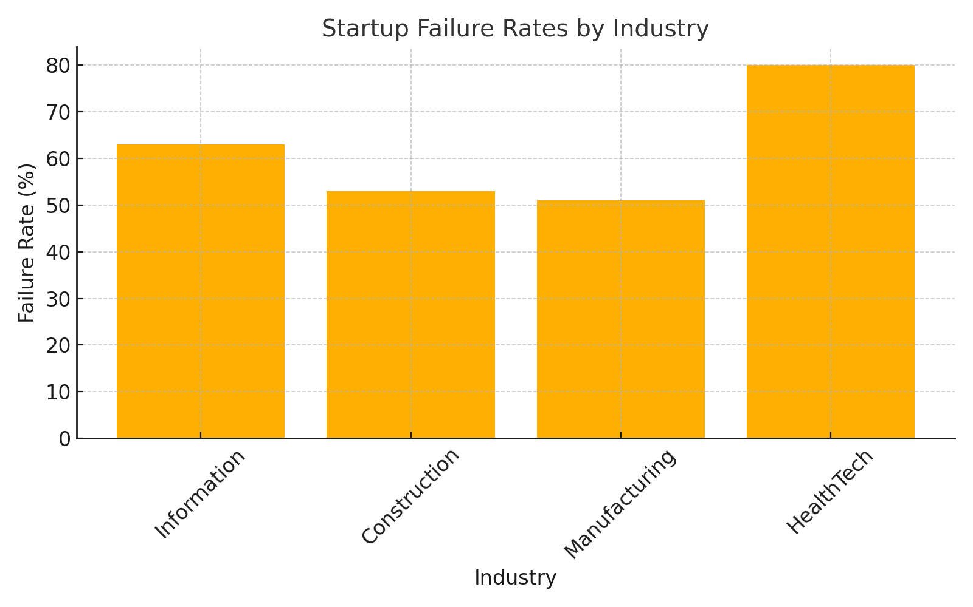

## Revenue Growth Impact by Strategy

This chart showcases the percentage increase in revenue achieved through various strategies employed by the Startup Catalyst Model.

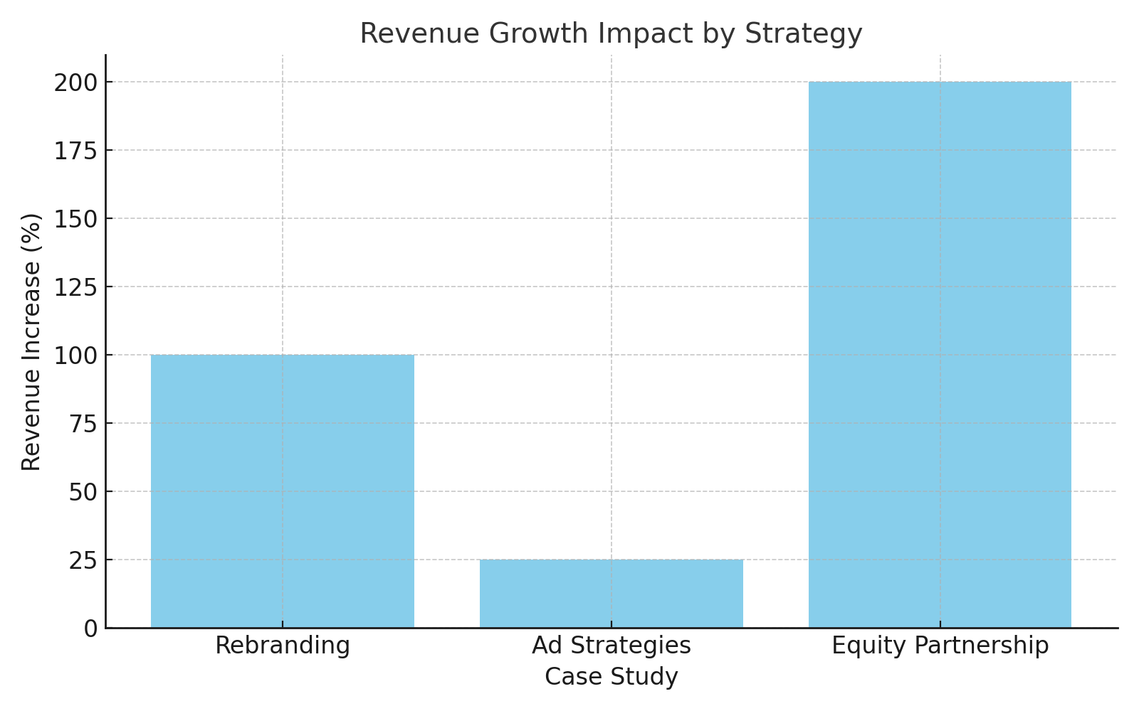

## Operational Efficiency Metrics Impact

The chart below highlights the effects of workflow automation and related operational improvements on productivity and overhead reduction.

